Page - Skill Builder Labs
- Main page

  - Change Name to Skill Builder Labs
  - Add:
    - Free or paid on each lab
    - Option to show Video-Guided
    - Option to show Instructor-Led
    - Option to show Individual or group Labs
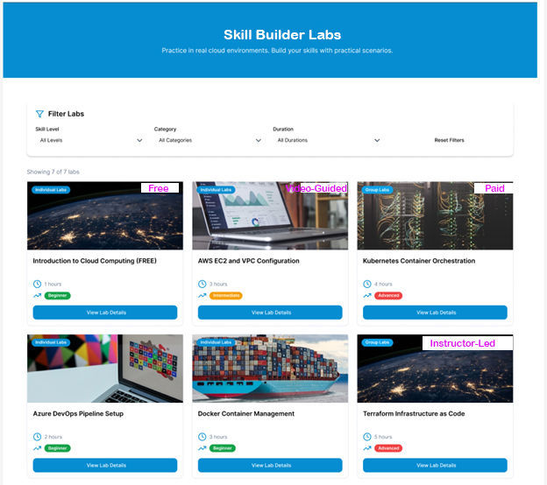
  - Filter Section (Dropdown):
    - Skill Level
    - Platform
    - Technology
    - Lab Type
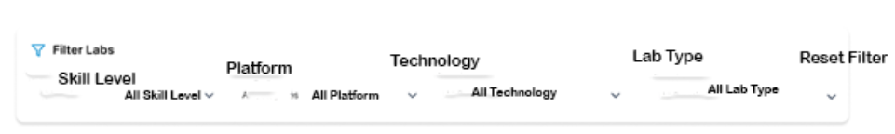
- Sub page for Individual Labs
Sub Page – Skill Builder labs
Each Lab
Each Lab page show (once click on View Lab Details)
  - Lab Name: Editable section to give name
  - First single line to show:
    - Skill Level: Beginner/ Intermediate/ Advance/ Expert
    - Platform: Linux/ Windows/ AWS/ Azure/ GCP/ Hybrid / Multi-Cloud
    - Technology: Administration/ Cloud Computing/ Big Data/ AI / ML/ DevOps/ Security/ Networking
    - Lab Type: Self-Paced/ Video-Guided/ Instructor-Led/ Challenged-Based
  - Second single line to show:
    - Rating (with icon): Editable section to give number
    - Enrollments Count (with icon): Editable section to give number
  - Third single line to show:
    - Duration (with icon): Editable section to write hours in numbers
    - Language (with icon): Editable section to give Language of training delivery
    - Fees (with icon): Editable section to give fees (Option to show standard fees and Discounted fees (if applicable))
  - Fourth single line to show (Optional):
    - Guided Video (with icon): Rounded Box to enable Checkbox
    - Fees (with icon): Editable section to give fees (Option to show standard fees and Discounted fees (if applicable))
    - If Guided (Checkbox selected), below information should be shown.
Guided Video
- Guided videos show step-by-step execution of tasks required to complete the lab.

  - Fifth single line to show (Optional):
    - Instructor-Led (with icon): Rounded Box to enable Checkbox
    - Fees (with icon): Editable section to give fees (Option to show standard fees and Discounted fees (if applicable)
      - If Instructor-Lead (Checkbox selected), below information should be shown.
Instructor-Led Lab Engagement Guidelines
- Display the instructor’s availability window (e.g., 9:00–10:00 PM IST / 9:00–10:00 PM EST, Monday to Saturday).
- Show an informational note indicating that a minimum of 24-48 hours’ notice is required to schedule instructor availability.
- The instructor engagement will be limited to the fixed duration of the lab.
- The instructor’s role is strictly to assist in completing the lab; conceptual discussions are not included.
- Instructor engagement is valid only for the specific lab purchased and cannot be transferred to another lab or user.
- Missed or unattended instructor sessions are considered consumed and are not eligible for rescheduling, unless explicitly approved.
- Instructor availability is subject to confirmation, even within the published time window.
- Any extension beyond the allocated lab duration will require additional purchase or approval, if applicable.
  - Sixth single line to show (Optional):
    - Lab Access (with icon): Rounded Box to enable Checkbox
    - Fees (with icon): Editable section to give fees (Option to show standard fees and Discounted fees (if applicable))
      - If Lab Access (check box selected), below information should be shown.

Lab Access Guidelines
- Display the lab’s availability window (e.g., 9:00–10:00 PM IST / EST, Monday to Saturday).
- Show a notice stating that 10–15 minutes’ advance notice is required to assign lab access.
- Lab access is provided only for the fixed duration of the lab.
- Access is valid exclusively for the purchased lab and cannot be transferred to another lab or user.
- Missed or unattended lab access is considered consumed and not eligible for reassignment.
- Any usage beyond the allocated duration will require an additional purchase.

  - Image: Editable section to add image
  - Video: Editable section to upload video (about intro of lab, means what they learn)
  - Description:
    - Write text
    - Option to add icons and give details

Left Box 1: Enroll Now
Note: Without buying labs, user can only view upto this one. Means, name, image, video, first, second and third line and description only.
Below this rest will be locked and can only view once users buy the labs.
  - Lab Overview:
    - Write text
    - Option to add icons and give details
    - Option to Add Image
  - Objectives:
    - Write text
    - Option to add icons and give details
  - Pre-requisites:
    - Write text
    - Option to add icons and give details
  - Lab Environment:
    - Write text
    - Option to add icons and give details
  - Lab Instructions:
    - Write text
    - Option to add icons and give details
    - Add Images
    - Add Code
    - Download Code (optional)
    - Ful fledge editor
  - Lab Completion:
    - Button to show Completed successfully
    - Rating: dropdown option to give rating from 1 to 5 (only admin can see)
    - Feedback: Give feedback (only admin can see and get email)
On the left of the page:
  - Box 2: Start Lab
    - Start Lab
      - Option to Pause the Lab/ Resume the Lab/ Cancel/ Closed the Lab
    - Timer to run as per duration
      - Once time gets completed, Start becomes Completed
      - If Pause or Resume timer get stop or start from pause
      - If cancel, timer reset
      - If Closed, Capture the lab completed in time
  - Box 3: Video-Guided (Optional)
    - Display an option to Start Video if the lab is purchased with Video-Guided access.

  - Box 4: Instructor-Led (Optional)
    - Display an option to Engage an Instructor if the lab is purchased as Instructor-Led.
    - Show the instructor’s availability window (e.g., 9:00–10:00 PM IST / EST).
    - Provide a button to send an email request for instructor availability.
    - Display informational text (e.g., Instructor availability requires a minimum of 24 hours’ notice).

  - Box 5: Lab Access (Optional)
    - Display an option to Lab Access if the lab is purchased along with Lab access.
    - Provide a button to send an email request for instructor availability.
      - Option to select Date (Display Calender)
      - Option to select Hour (Display Hour in 24 hour format)
      - Option to select Mnts. (Display Minutes in 60 minutes format)
    - Display informational text (e.g., Lab access requires a minimum of 10-15 minutes notice to create and assign lab and you will received email with credentials).

Sample page given below
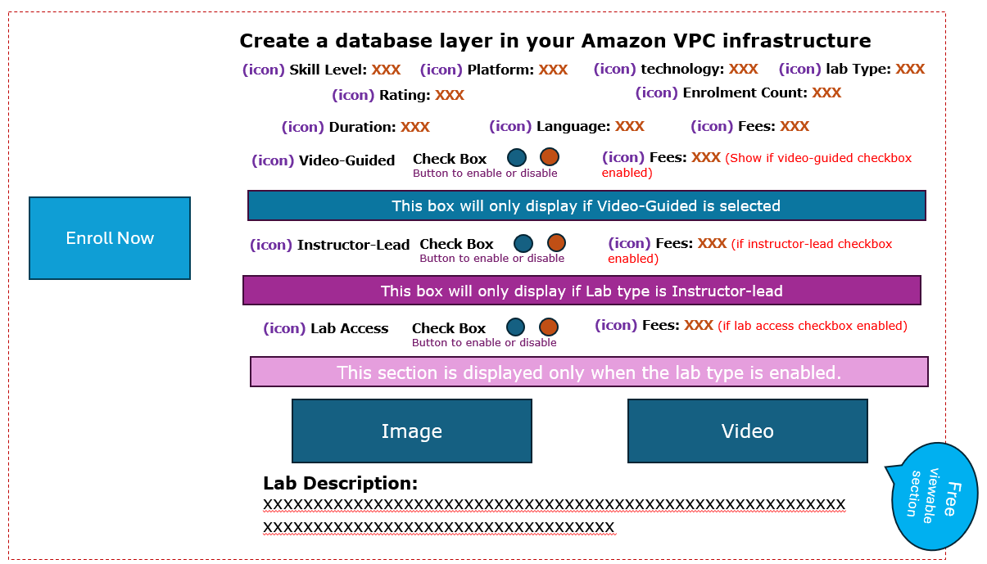

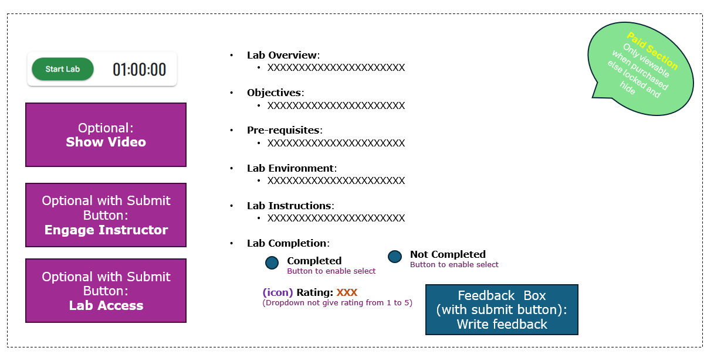

- Sub page for Group Labs

Sub Page
Group of Labs of Skill Builder labs
- Lab Name: Editable section to give name
- First single line to show:
    - Skill Level: Beginner/ Intermediate/ Advance/ Expert
    - Platform: Linux/ Windows/ AWS/ Azure/ GCP/ Hybrid / Multi-Cloud
    - Technology: Administration/ Cloud Computing/ Big Data/ AI / ML/ DevOps/ Security/ Networking
    - Lab Type: Self-Paced/ Video-Guided/ Instructor-Led/ Challenged-Based
- Second single line to show:
    - Rating (with icon): Editable section to give number
    - Enrollments Count (with icon): Editable section to give number
- Third single line to show:
    - Duration (with icon): Editable section to write hours in numbers
    - Language (with icon): Editable section to give Language of training delivery
    - Fees (with icon): Editable section to give fees (Option to show standard fees and Discounted fees (if applicable))

- Fourth single line to show (Optional):
    - Guided Video (with icon): Rounded Box to enable Checkbox
    - Fees (with icon): Editable section to give fees (Option to show
    - standard fees and Discounted fees (if applicable))
    - If Guided (Checkbox selected), below information should be shown.
Guided Video
- Guided videos show step-by-step execution of tasks required to complete the lab.

- Fifth single line to show (Optional):
    - Instructor-Led (with icon): Rounded Box to enable Checkbox
    - Fees (with icon): Editable section to give fees (Option to show standard fees and Discounted fees (if applicable)
    - If Instructor-Lead (Checkbox selected), below information should be shown.
Instructor-Led Lab Engagement Guidelines
- Sixth single line to show (Optional):
    - Lab Access (with icon): Rounded Box to enable Checkbox
    - Fees (with icon): Editable section to give fees (Option to show standard fees and Discounted fees (if applicable))
    - If Lab Access (check box selected), below information should be shown

Lab Access Guidelines

- Image: Editable section to add image
- Video: Editable section to upload video (about intro of lab, means what they learn)
- Description:
    - Write text
    - Option to add icons and give details
- Each lab Name
    - Lab name – 1 (Unless purchased user can only view, a to e section like individual labs)
    - Lab name – 2 (Unless purchased user can only view, a to e section like individual labs)
    - Lab name - 3 (Unless purchased user can only view, a to e section like individual labs)

- Lab Completion:
    - Button to show Completed successfully after completing all labs (Once user click on Button successfully and auto Certificate or badge generated and mailed to user)
    - Rating: dropdown option to give rating from 1 to 5 (only admin can see)
    - Feedback: Give feedback (only admin can see and get email)

Lab instruction page (example)
